**Adeel Mustafa**

**BIT-23F-028**

**Lab Task 06**

**Task#01**

Write a Python function that takes a number as input and returns the sum of its digits.

**Code and Output:**

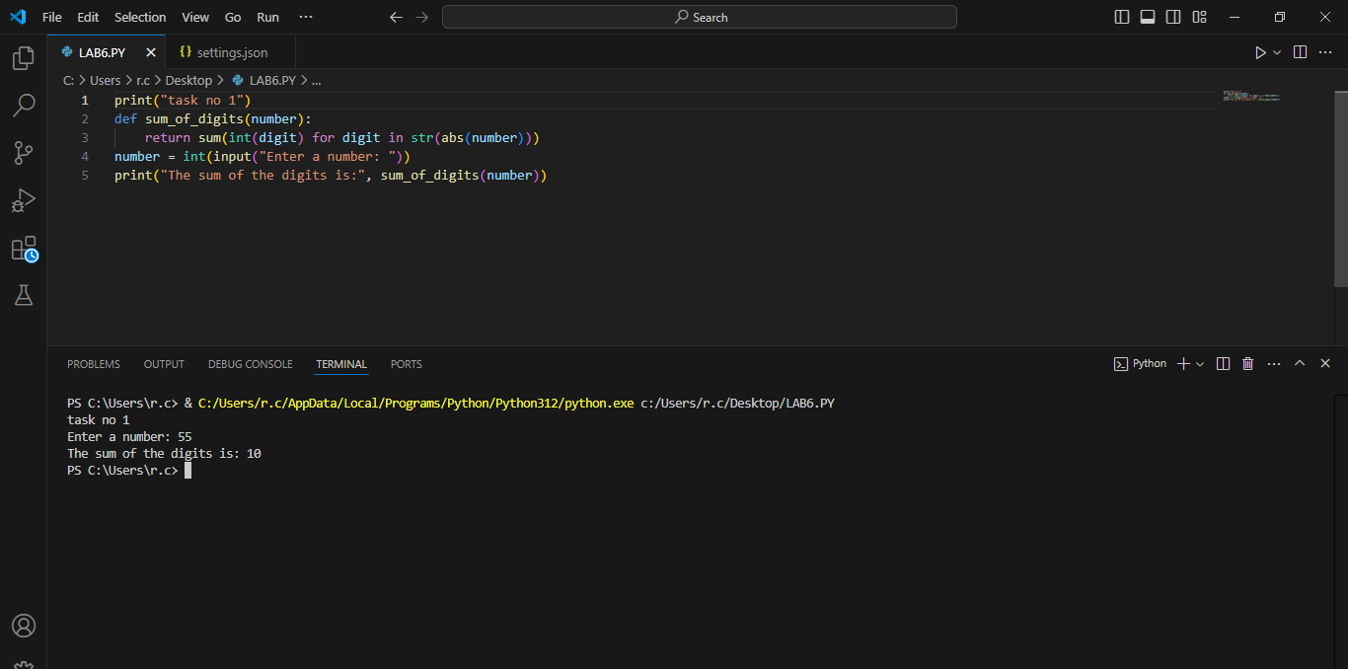

**Task#02**

Write a Python function that takes a sentence as input and returns the number of words in it.

**Code and Output:**

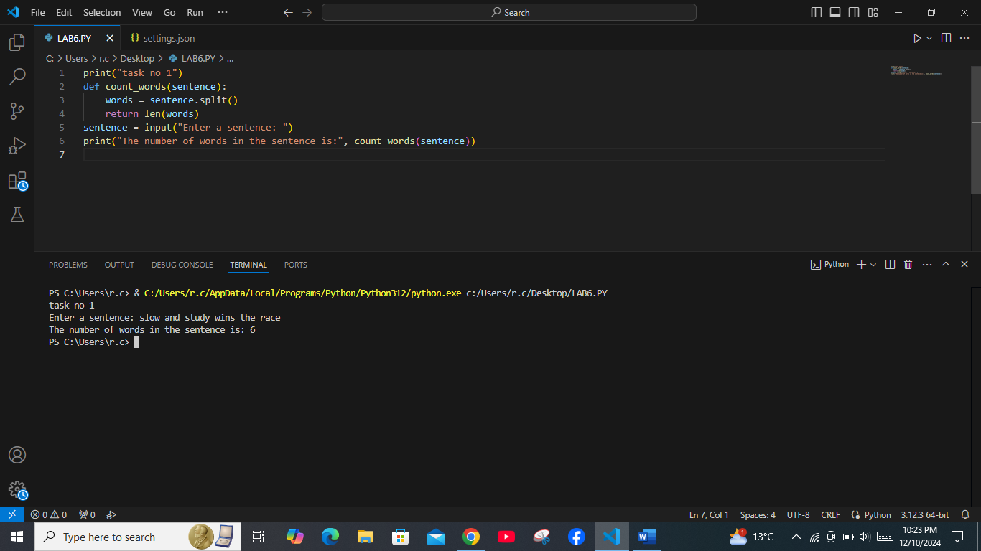

**Task#03**

Write a Python function that takes an integer and returns whether the number is even or odd.

**Code and Output:**

